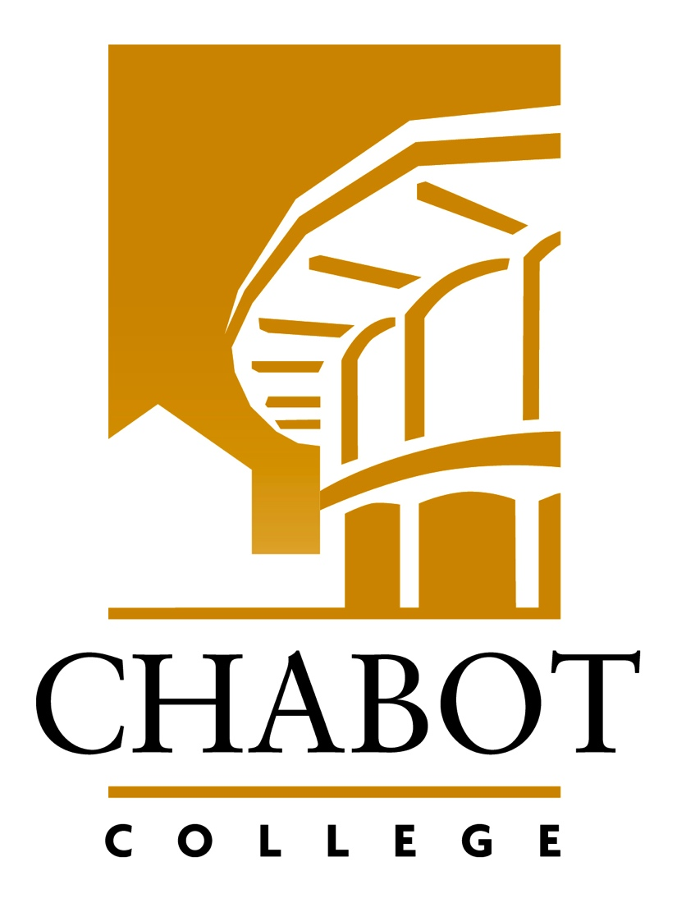
YES, I want to make a gift to The Friends of Chabot College!

Checks are made payable to: The Friends of Chabot College
The Friends of Chabot College, 25555 Hesperian Blvd., Hayward, CA 94545
Tel: 510.723.7091 Fax: 510.723.7026 Email: mochoa@chabotcollege.edu

Enclosed is my check for: $1,000 $500 $250 $100 Other $ ________

I prefer to charge my donation to: Visa MasterCard

Account #__________________________ Exp. Date __________

Signature__________________________________________________Date_____________________

Your Name (please print)______________________________________________________________

Address/City/ZIP____________________________________________________________________

Telephone ______________________________________ Mobile_____________________________

E-mail____________________________________________________

Please designate my gift for the following purpose:

Where need is greatest (Unrestricted)

Scholarship for students (Name of Scholarship)____________________________________________

Other_____________________________________________________________________________

My contribution is a Memorial or Tribute gift, and I have filled out the information below.

This gift is a Memorial or Tribute in honor of______________________________________________

Please send a card announcing the gift to:

Name______________________________________________________________________________

Address/City/State/ZIP________________________________________________________________

